When Lies and Treachery Take Root
APRIL 5, 2023 / DR. PETER MEAD\
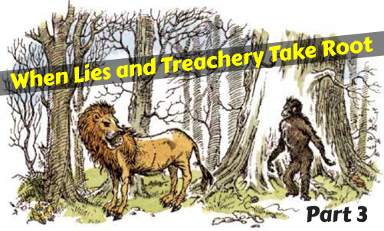

Different gods are treated as one. A Lamb spoke up, “Please, I can’t understand. What have we to do with the Calormenes? We belong to Aslan. They belong to Tash. They have a god called Tash. They say he has four arms and the head of a vulture. They kill Men on his altar. I don’t believe there’s any such person as Tash. But if there was, how could Aslan be friends with him?” The underlying impulse of tyrants is always a collective uniformity. There is no space for diversity of thought or diversity of religion. And so, like a recurring refrain, the religions are pushed together and effectively true religion is pushed out. It was true in Narnia. It was true in Nazi Germany. It was true in the Soviet Union. It is true in China. It is always the same. There is always one version of religious thought allowed, and the new leaders get to define it.

The God question is the best question to ask. Once the Lamb had spoken, we are told that they knew this was the best question anyone had asked yet. It always is. In a world where the boundaries are blurred and the gods are blended together, the most important question is always to ask about the true God. After all, He will always be different, and better, than their imposed amalgam deity.

Good questions incite aggressive answers. The Ape jumped up and spat at the Lamb. “Baby!” he hissed. “Silly little bleater! Go home to your mother and drink milk. What do you understand of such things?” The subjects are ridiculed if they dare to question. The experts know best. They always do. If you question them, then you discover that you are questioning “The Science” itself. Abusive relationships do not always require shouting and overt aggression. However, the presence of shouting and overt aggression tends to be a good indicator of an abusive relationship.

The blending of gods will always mean the diminishing of the true God. The Ape declared, “Tash is only another name for Aslan. All that old idea of us being right and the Calormenes wrong is silly. We know better now. The Calormenes use different words but we all mean the same thing. Tash and Aslan are only two different names for you know Who. . . . Tash is Aslan: Aslan is Tash.” The true God always seems to be reduced when the proud claim to have new insight. They know what is best and they should be trusted with the future. But Lewis described how every tail was down, and every whisker drooped. Except one. The Ginger Cat asked a clarifying question – “Aslan means no more than Tash? . . . I think I am beginning to understand.” When we add another god to the true God, the true God becomes nothing more than that other so-called god. You can add nothing to the true God and make him better. Some might use the ecumenical impulse for their own gain, but the Narnian beasts were right in their downed tails and drooped whiskers.

Silencing of contrary voices is always required for a tyrannical coup. King Tirian cried with a loud voice and was silenced. “If he had been allowed to speak, the rule of the Ape might have ended that day; the Beasts might have seen the truth and thrown the Ape down.” Instead, with violence, the Ape put down the truth-crier. “Take him where he cannot hear us, nor we hear him.” Which is more important, that he not hear their lies? Or that they do not hear his truth? Since tyranny is always a fragile house of cards, it must surely be the latter. Therefore, there will be ruthless silencing, censoring, cancelling and de-platforming of any counter-opinions. After all, it is for the good of the people. The destruction of free speech should always be a big red flag to thinking people.

REPORT THIS AD
The pantomime leader is ridiculous, but you may be tempted to believe that he is real until you remember the truth. In the next chapter, the Beasts are crying out to Aslan as he is paraded in front of them, briefly. King Tirian looked on from a distance, “He had not expected Aslan to look like that stiff thing which stood and said nothing. But how could he be sure? For a moment horrible thoughts went through his mind: then he remembered the nonsense about Tash and Aslan being the same and knew that the whole thing must be a cheat.”
The doddery old donkey in fancy dress almost fooled him, but the truth won out.

