Be Careful What You Read… C.S. Lewis’ Literary Encounter with George MacDonald
Posted on March 4, 2013 by Brenton Dickieson
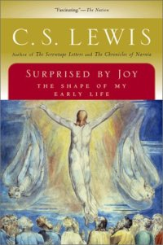
Perhaps one of C.S. Lewis’ more famous—or infamous—quotations is this:
“A young man who wishes to remain a sound Atheist cannot be too careful of his reading” (Surprised by Joy, 182).
Hidden in this 20th century tweet is the idea that serious study will bring an intelligent and engaged thinker to a belief in God. The pre-Christian Lewis, however, was besieged not just by the philosophical proofs for the existence of God, but by the spiritually infused worldviews of the writers he most admired.
“All the books were beginning to turn against me. Indeed, I must have been as blind as a bat not to have seen, long before, the ludicrous contradiction between my theory of life and my actual experiences as a reader. George MacDonald had done more to me than any other writer; of course it was a pity he had that bee in his bonnet about Christianity. He was good in spite of it. Chesterton had more sense than all the other moderns put together; bating, of course, his Christianity. Johnson was one of the few authors whom I felt I could trust utterly; curiously enough, he had the same kink. Spenser and Milton by a strange coincidence had it too. Even among ancient authors the same paradox was to be found. The most religious (Plato, Aeschylus, Virgil) were clearly those on whom I could really feed.” (Surprised by Joy, 201-202).
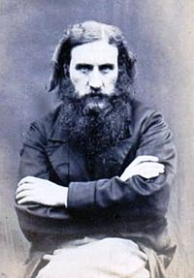
The chief offender was George MacDonald, the 19th century preacher and writer of faerie tales. In Surprised by Joy (1955), Lewis shares the moment of his first encounter with MacDonald, when he was 18, just before WWI:
“Turning to the bookstall, I picked out an Everyman in a dirty jacket, Phantastes, a Faerie Romance, George MacDonald. Then the train came in. I can still remember the voice of the porter calling out the village names Saxon and sweet as a nut—‘Bookham, Effingham, Horsley train.’ That evening I began to read my new book.
“The woodland journeyings in that story, the ghostly enemies, the ladies both good and evil, were close enough to my habitual imagery to lure me on without the perception of a change. It is as if I were carried sleeping across the frontier, or as if I had died in the old country and could never remember how I came alive in the new” (170-171).
I’ve posted the March 7, 1916 letter to his boyhood friend, Arthur Greeves, Lewis’ teenage version of the same moment. He tells much the same story of discovering “another author to add to our circle” in a “rather tired Everyman copy”:
“Have you read it? I suppose not, for if you had, you could not have helped telling me about it. At any rate, whatever the book you are reading now, you simply MUST get this at once.”
Lewis stayed with MacDonald through his 20s. On January 11, 1923, he writes in his diary:
“After this I read Macdonald’s Phantastes over my tea, which I have read many times and which I really believe fills for me the place of a devotional book. It tuned me up to a higher pitch and delighted me.”
The spell continues. On Aug 7, 1918, he says to Arthur, “In my present mood few things have pleased me more than Macdonald’s ‘The Goblin and the Princess.’” In a period of great uncertainty and financial pressure, Lewis “yielded to a long-treasured desire” and ordered 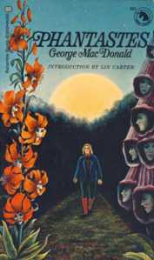MacDonald’s Lilith (Aug 19, 1925), which he later re-read when he was feeling down (June 25, 1926). His letters are filled with joyous moments—where the phrase, “I read another MacDonald,” is a clue to a correspondent that his time is well spent.

I have read both The Princess and the Goblin (1872) and The Princess and the Curdie (1883), and loved them both. Recently, I read through Phantastes for the first time, and except for the Cosmo Story-Within-a-Story, I am sad to say that I was not mystified by MacDonald’s Faerie Romance. It was a good story, but was not, for me, the threshold of the region of awe as it clearly was for Lewis.
But for Lewis, in any case, the siege was successful. The spell worked its way upon the victim in the end. By the close of the 1920s, Lewis had reluctantly accepted the idea of a God. As he worked through the implications of his theism and considered the case for Christianity, it is natural that he turned to George MacDonald, the one who carried him across the frontier in the first place. He connected the idea of conversion with death, linking St. Paul’s idea in Galatians and Romans with MacDonald’s idea. Indicative of this Emmaus Road reconsideration of MacDonald’s works is Lewis’ letter to Arthur on Sep 1, 1933:
“I have just re-read Lilith and am much clearer about the meaning.”
The letters of the 1930s—we have no journal from this period—are filled with references to MacDonald as Lewis is drawn deeper and deeper into the Christian story. And when he becomes a public figure, it is George MacDonald who is so frequently recommended in his correspondence.
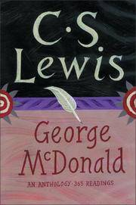

One of these letter friends, Mary Neylan, also became a Christian. Years later when C.S. Lewis created an anthology of MacDonald’s works, he dedicated it to Mary Neylan, who “got more out of him than anyone else to whom I introduced his books” (May 20, 1945).
Classically, Lewis wrote this of his first encounter with MacDonald: “That night my imagination was, in a certain sense, baptized; the rest of me, not unnaturally, took longer” (Surprised by Joy 172).” It is not insignificant to note, though, how he finishes the chapter entitled “Check” in his spiritual autobiography:
“I had not the faintest notion what I had let myself in for by buying Phantastes” (Surprised by Joy 172).

Atheists really must be more careful in their reading.

--Article by renowned Lewis scholar Professor Dr. Brenton Dickieson
The Princess and Curdie continues the adventures of Princess Irene and Curdie the miner’s son. Curdie is given a quest. He must travel to Gwyntystorm and there join with Princess Irene in saving the King from a sinister and deadly plot spun by the King’s own ministers. With the help of a magical gift from the great-great-grandmother’s fire-roses, Curdie has a secret power to discern who is a friend and who is an enemy. But the real power is in his heart and in the heart of the Princess: to do better, grow better, and be better, for only by the power of goodness will the King be saved. The Princess and Curdie is a timeless classic from George MacDonald, worth reading again and again and again.

